|  |  |  |  |  |  |
| --- | --- | --- | --- | --- | --- |
| Date | 7-Dec-22 | | | Tester Name | Mohammad Yusuf |
| Environment | Penfax - Test | | | Login used |  |
| Operating System | Windows | Version: | Update: | | |
| Software Used | Select Software | Version: | Update: | | |
| Select Software | Version: | Update: | | |
| Release version |  | | | | |
| Title |  | | | | |
| Test Type | Regression | | | | |
| Test Scenario |  | | | | |
|  |  | | | | |
| Expected Results |  | | | | |
| Pass/Fail | Select | | | JIRA# | N/A |

Describe your steps with screenshots:   
Search the MEPP Retirement Member in Benefit Event Search

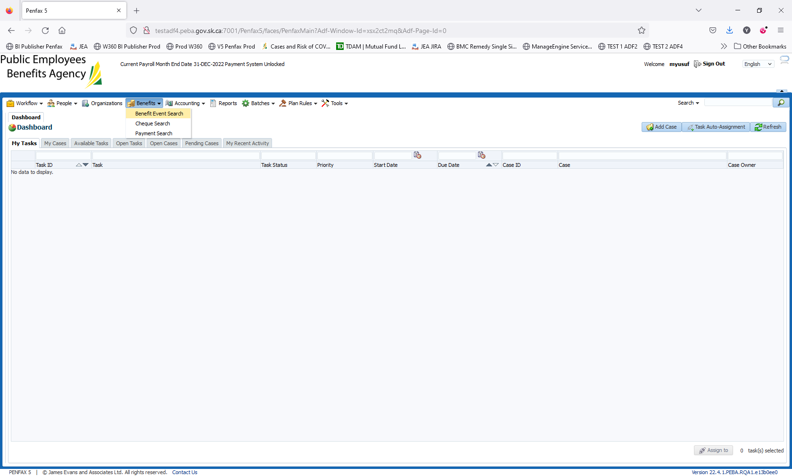

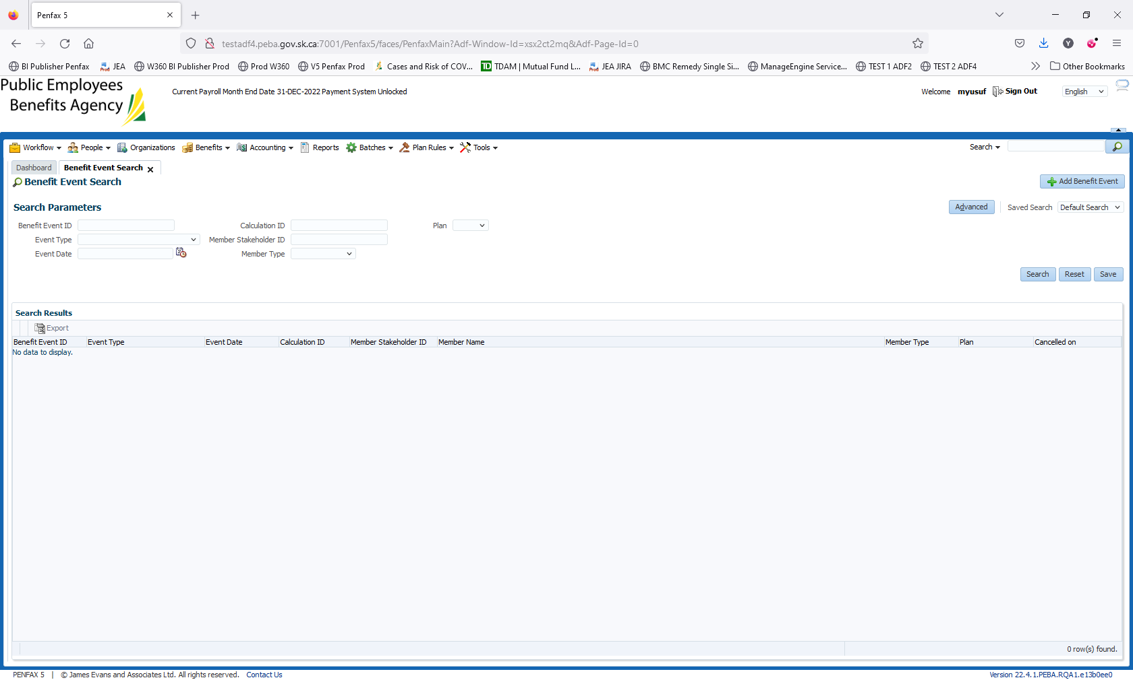

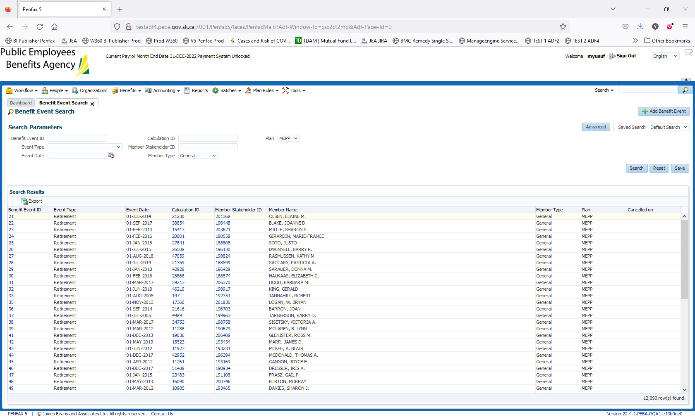

Select a member Stk holder 196448. Click on Add Benefit Event

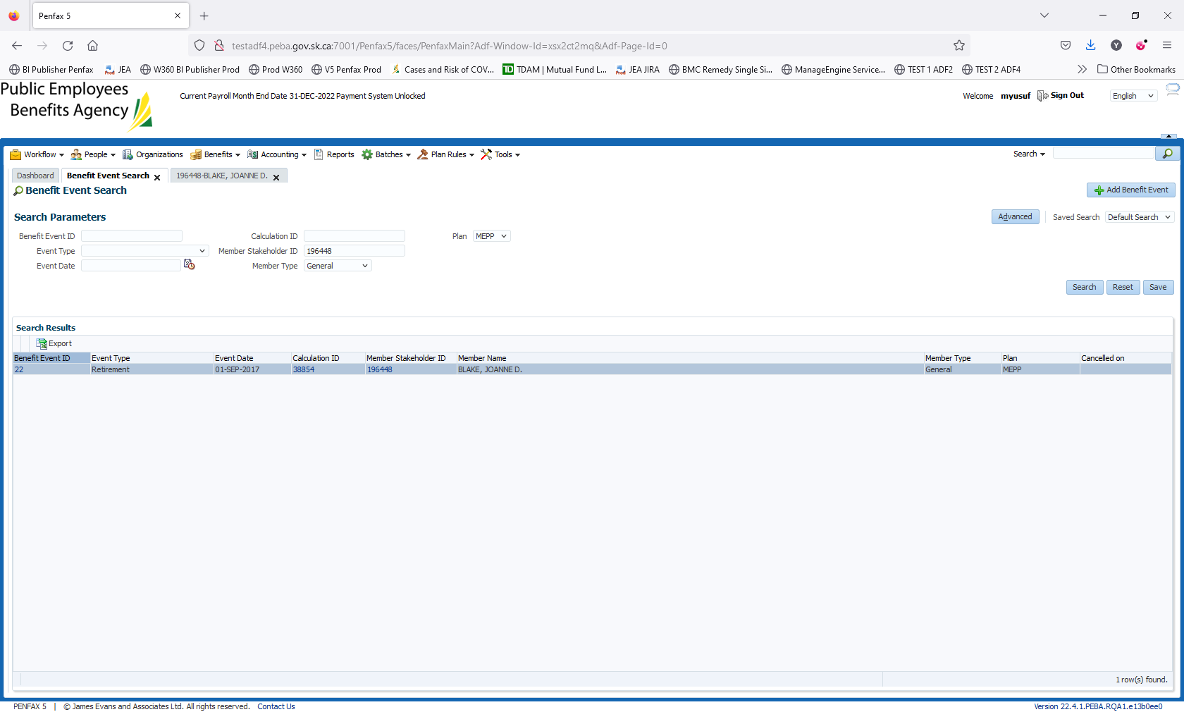

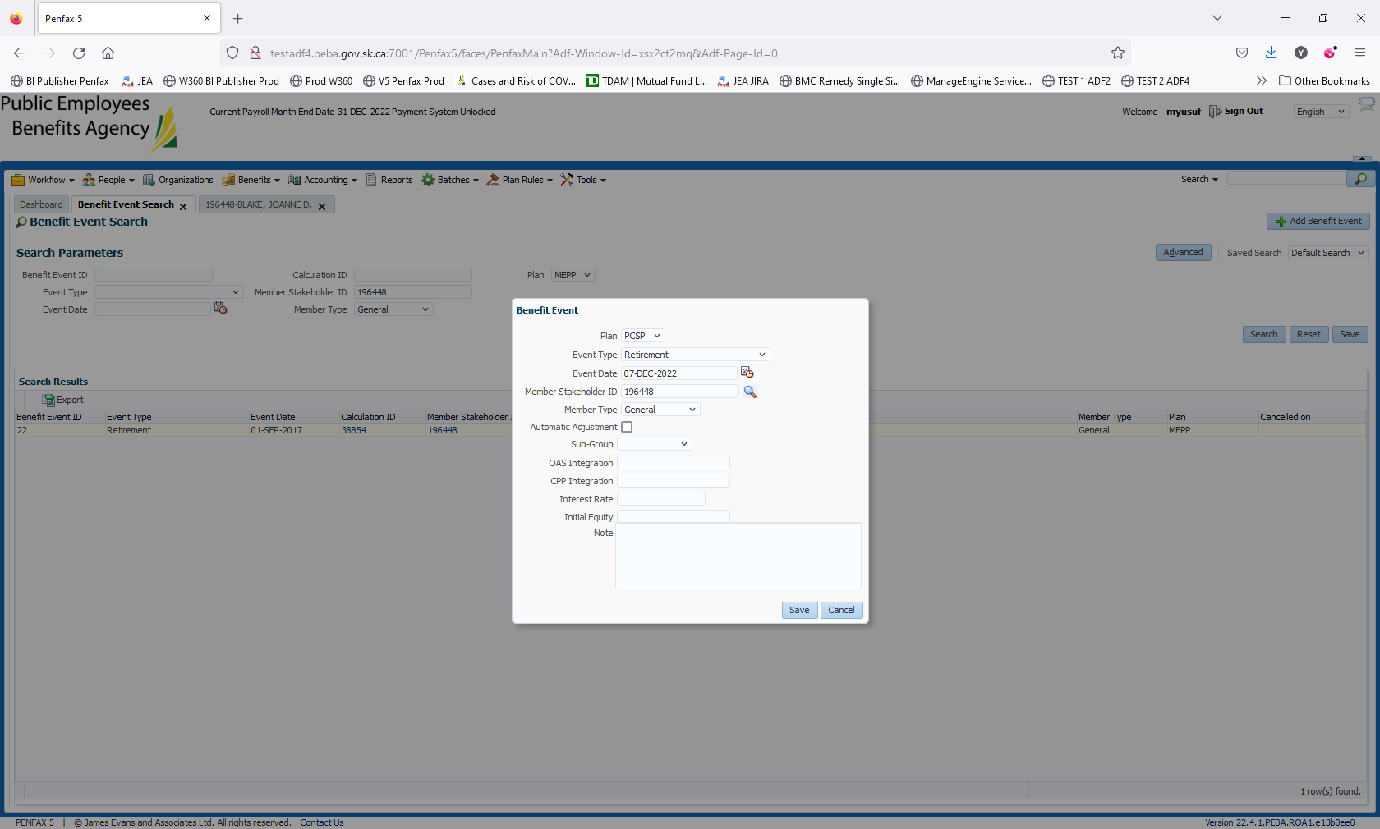

Click on Save. Under Benefits Tab -> click on Add

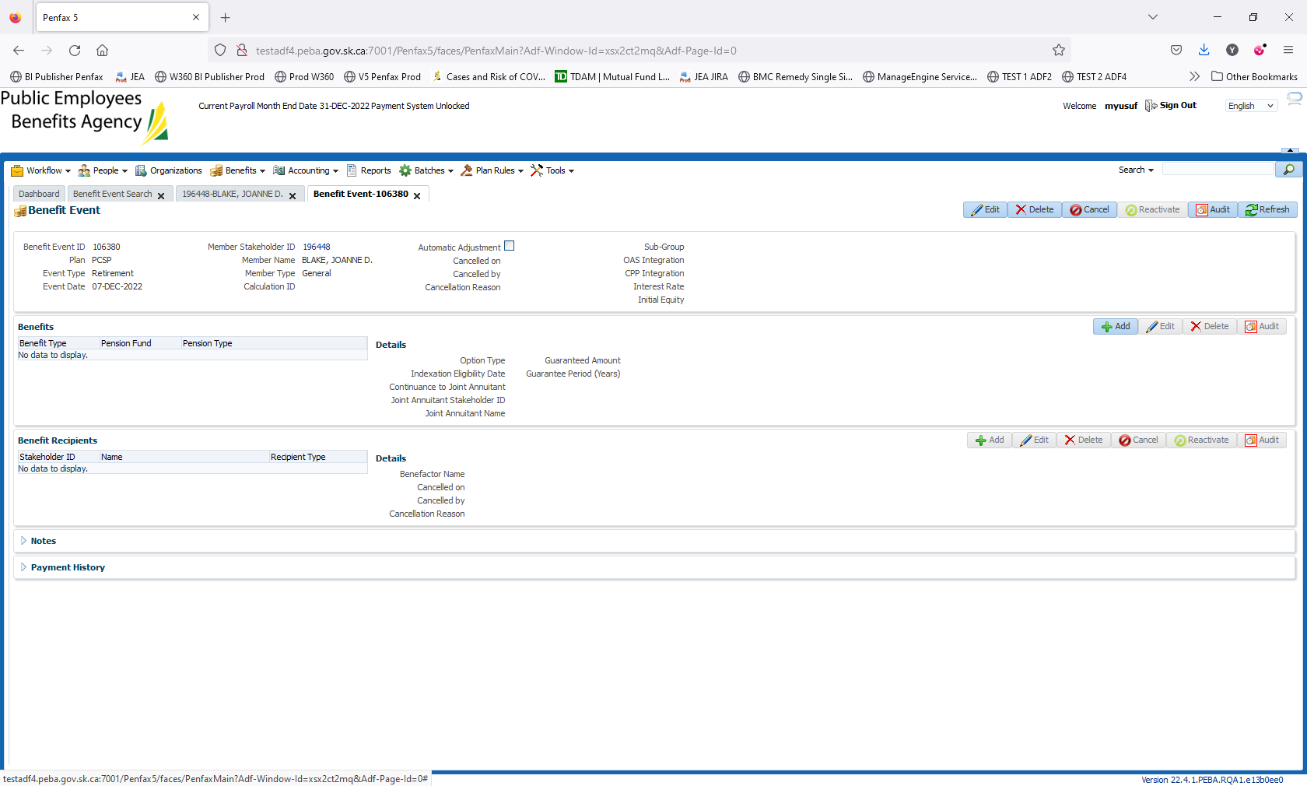

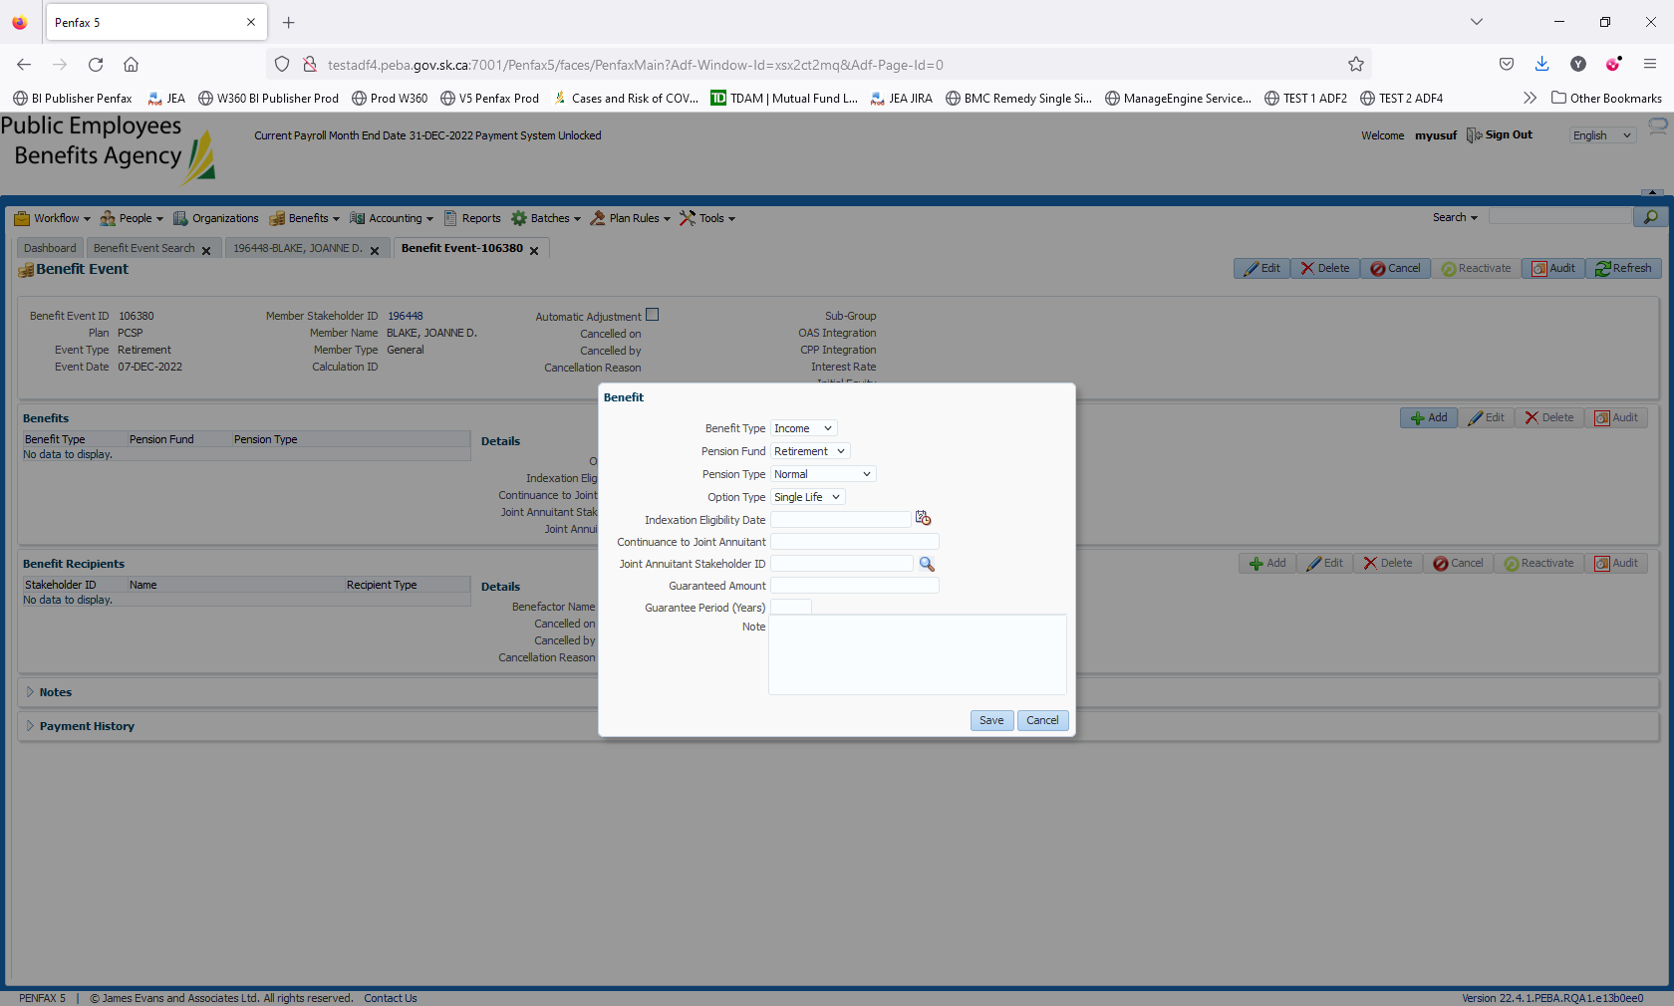

Click on Save. Navigate to Benefit Recipient. Click Save

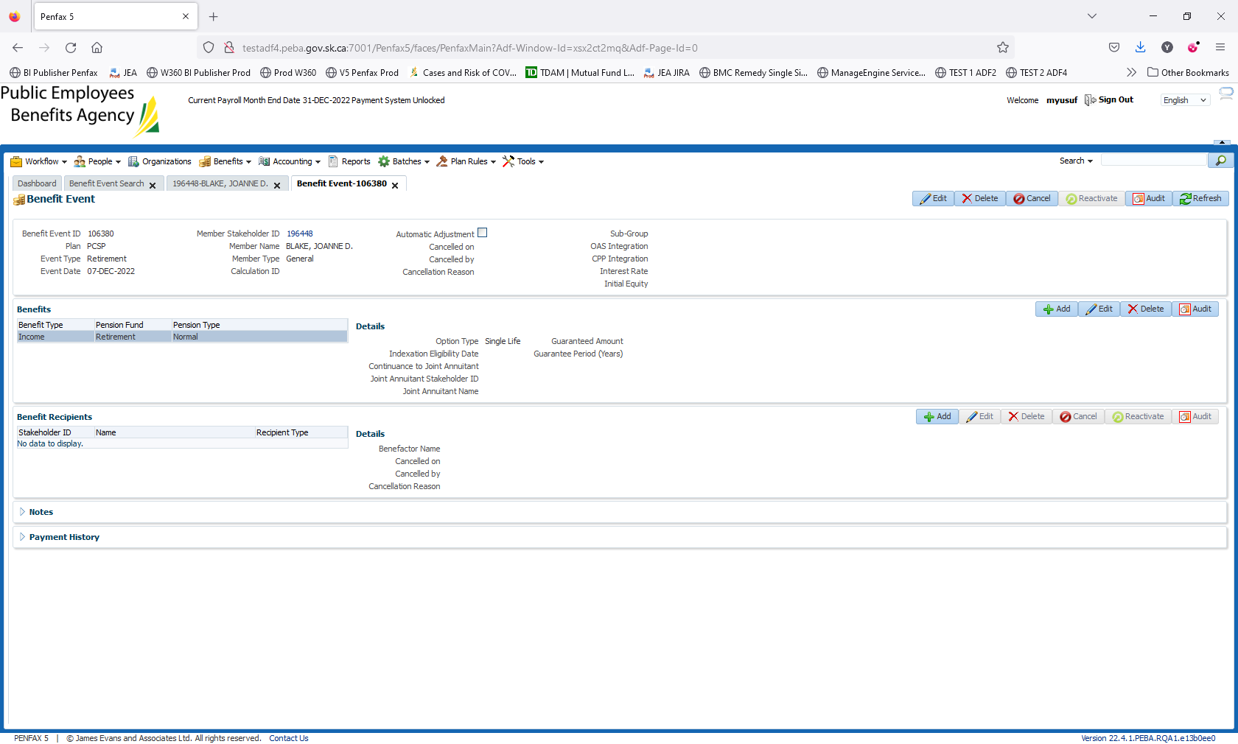

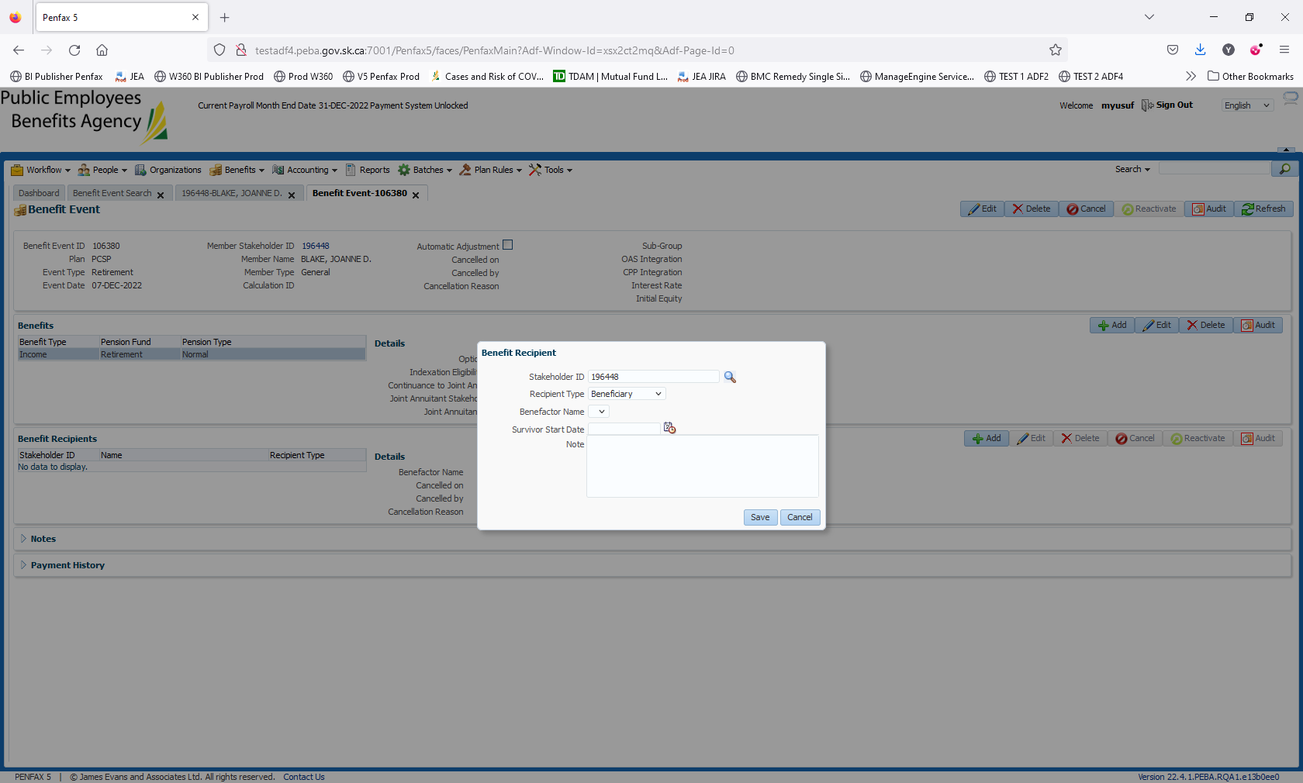

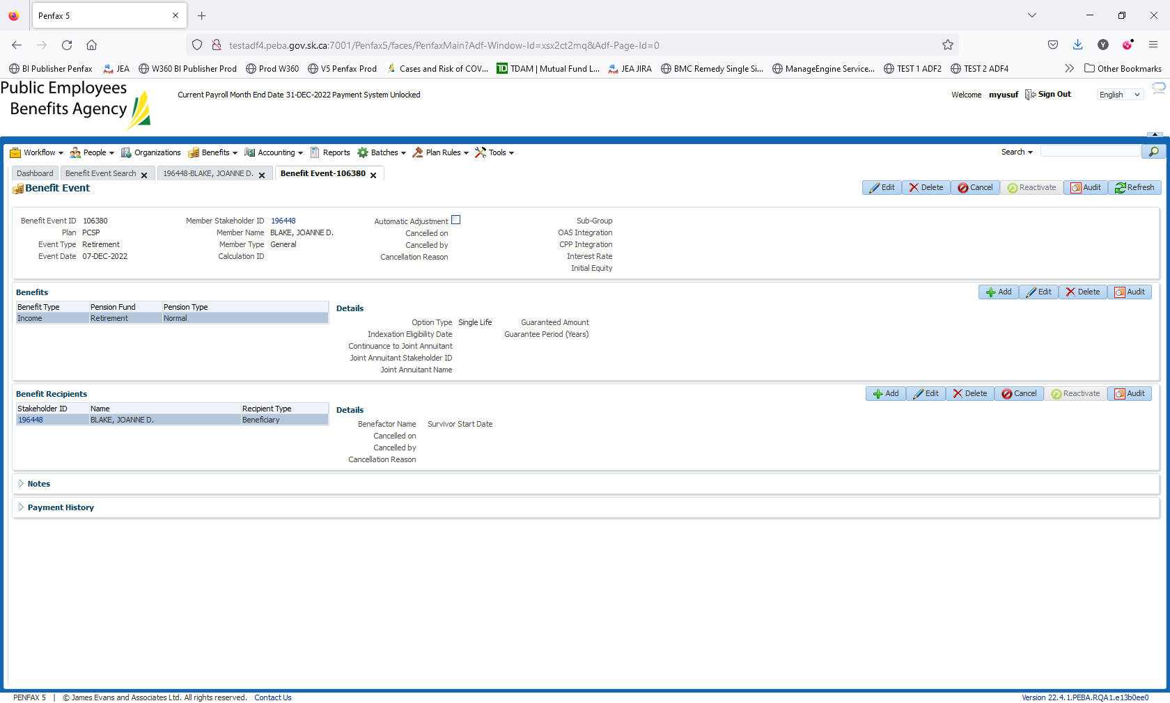

Navigate to Member profile 196448 to view if pension has been setup under Benefits.

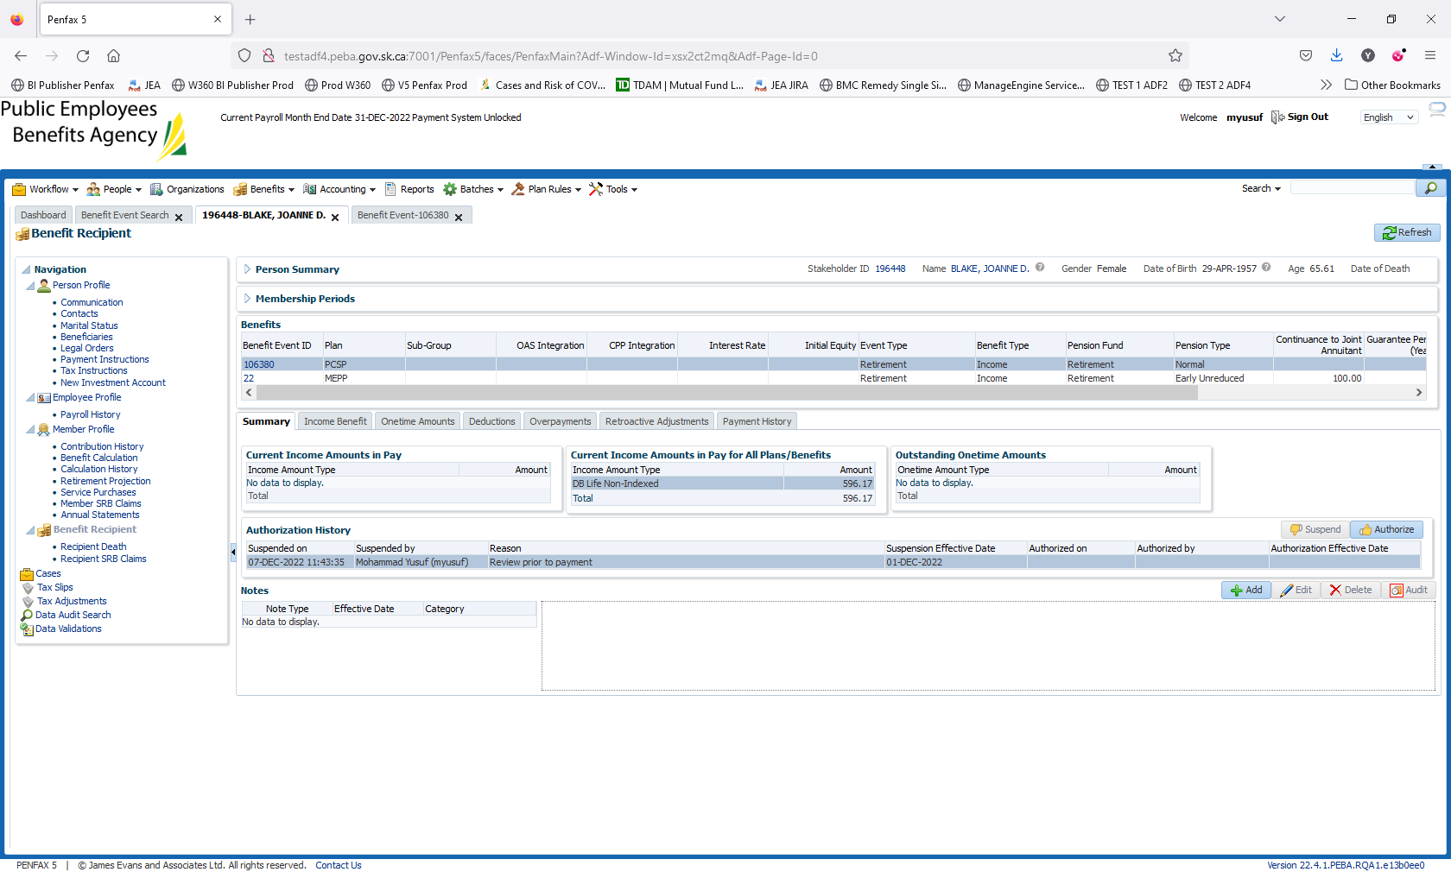

Click on Authorize.

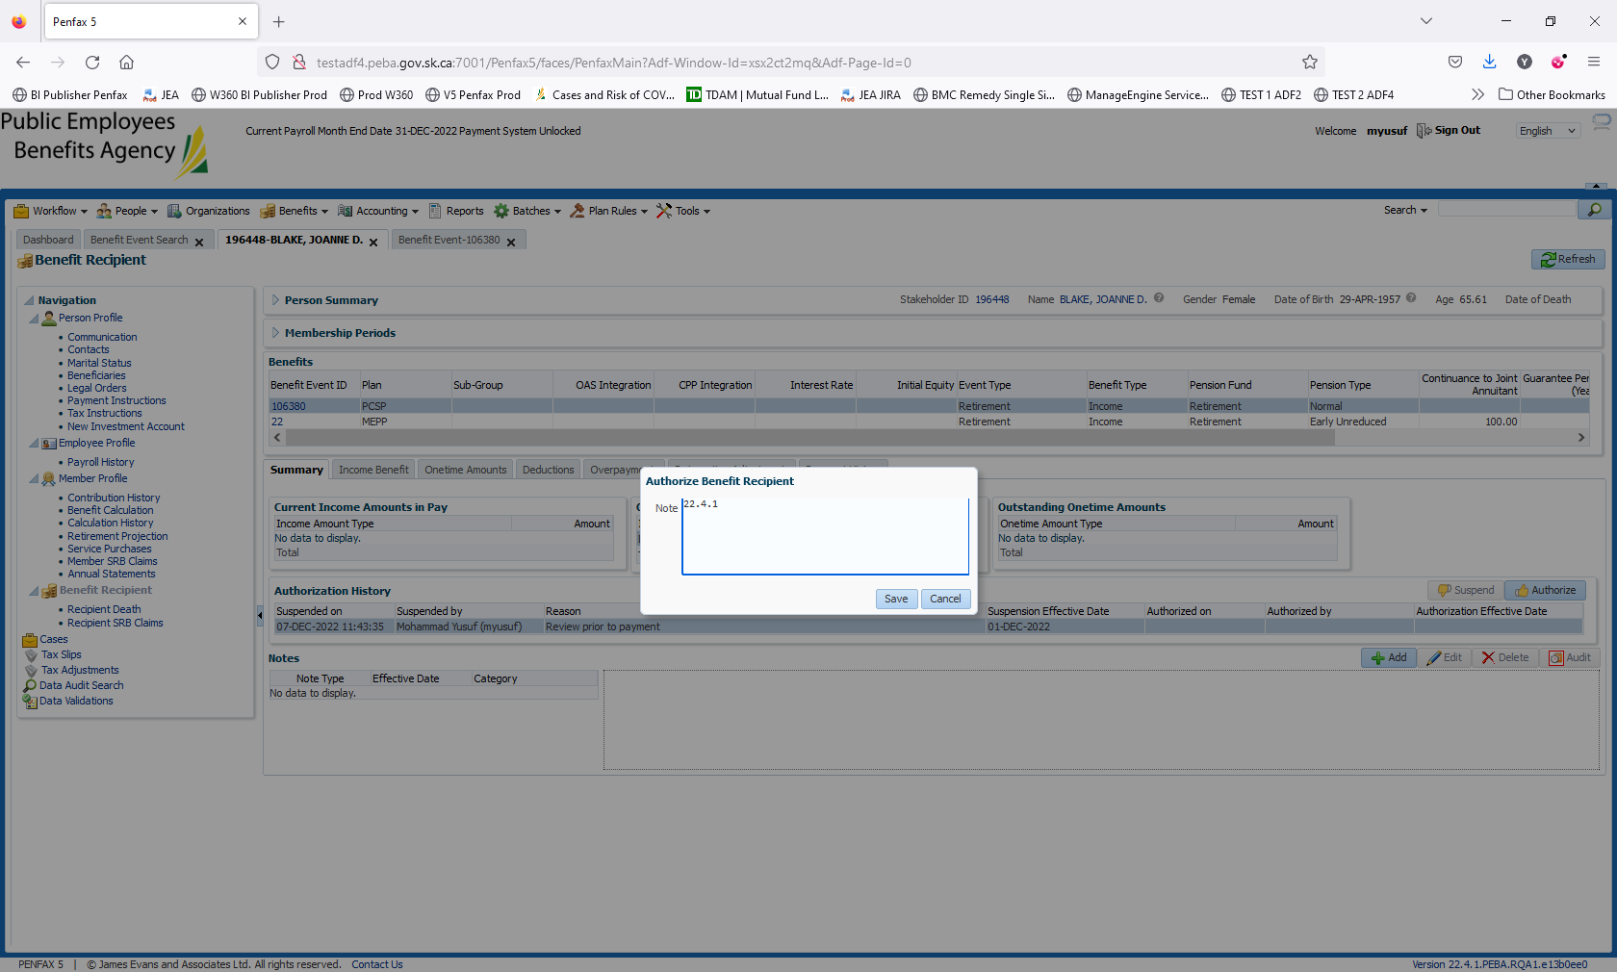

Save it.

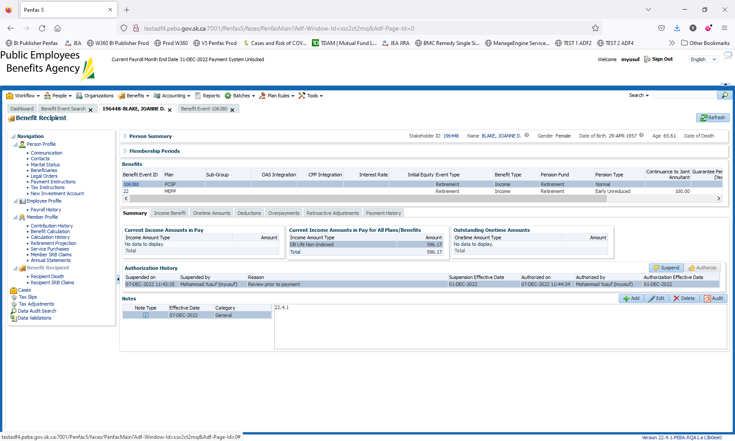

New PCSP Pensioner has been setup. To add pension details. Navigate to Income Benefit -> click on Add

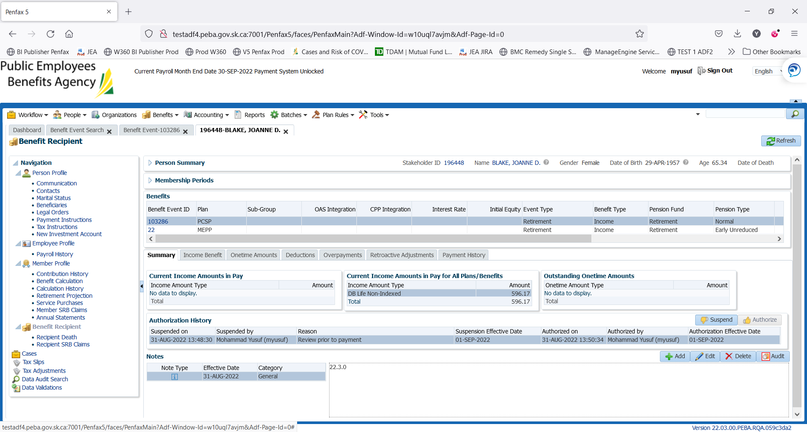

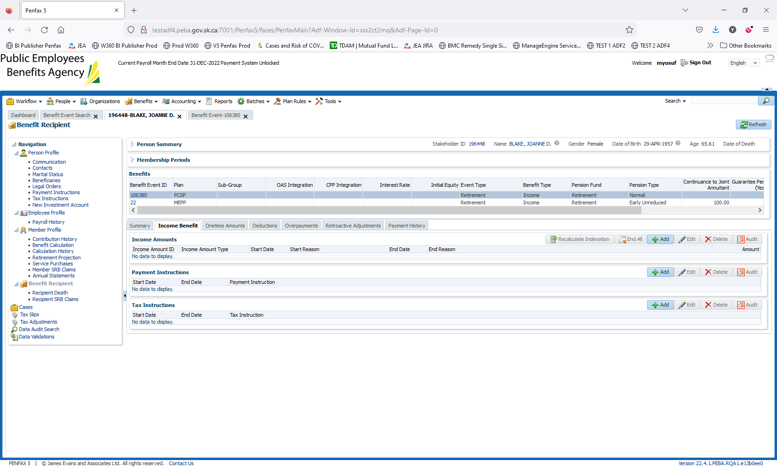

Add the details in Income Amount. Save it

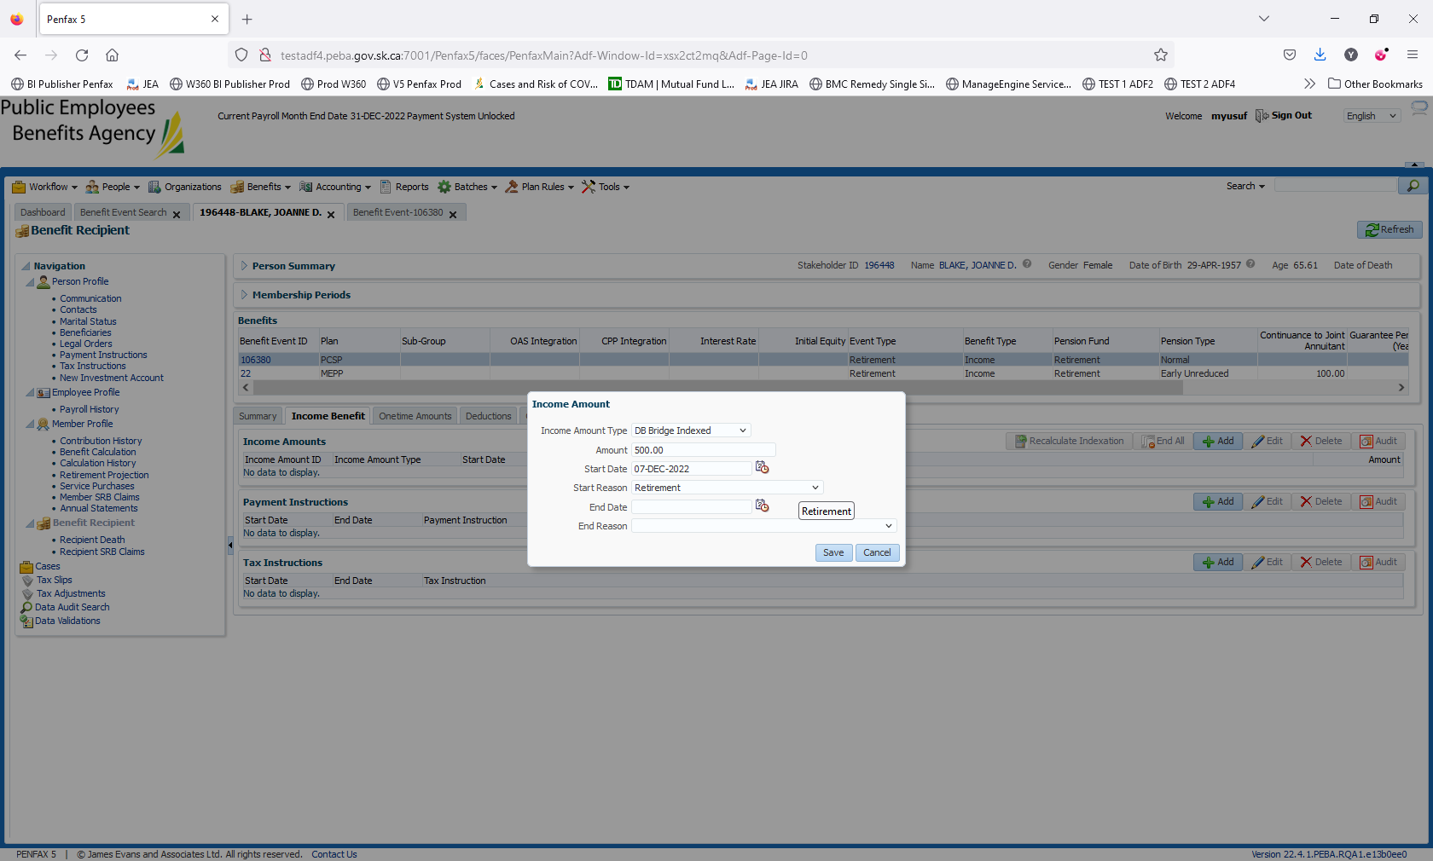

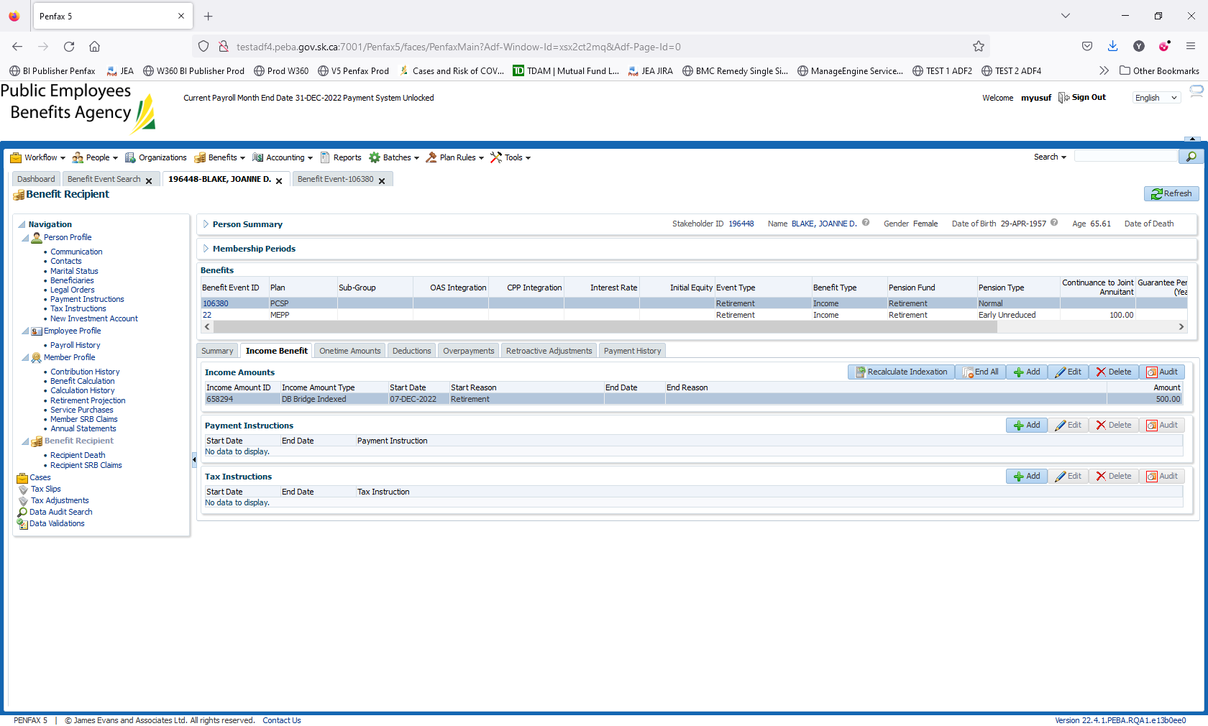

Please do not forget to add Payment & Tax Instructions. For this member both the details were added.

Payment

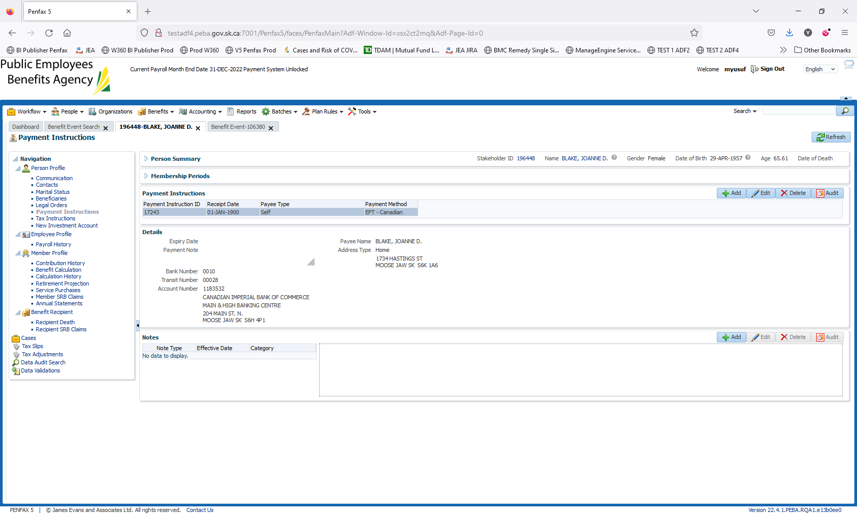

Tax   
